The Future of Lodging Summit 2022 SUMMARY & ACTION STEPS
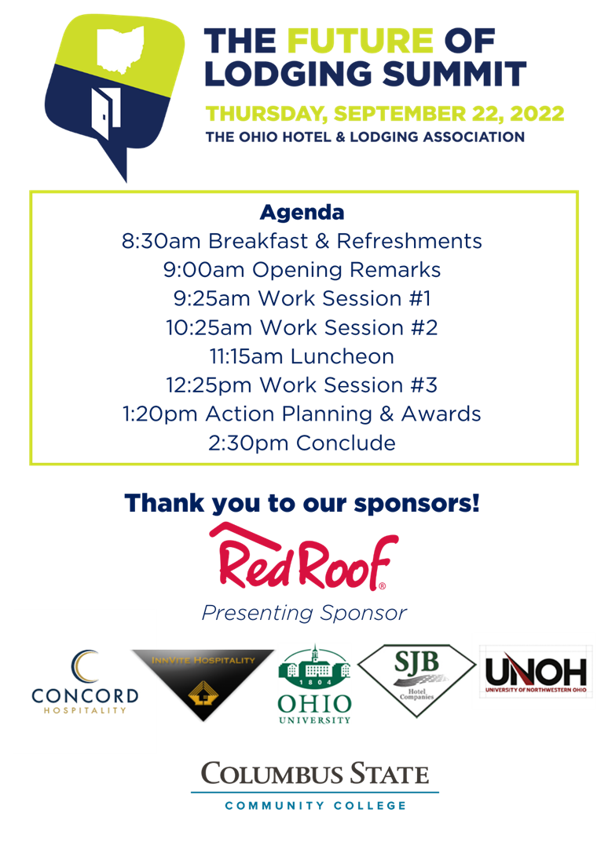
Goal of Event:
Address current issues and futures needs in attracting and retaining employees for a career in the lodging and hospitality industry. Design a plan of action to address the information gathered in the three work sessions.


The Ohio Hotel & Lodging Association held the first education & workforce summit for Hoteliers, Educators, Students and Hospitality Partners in September 2022. The Education & Workforce Development Committee began working on this idea after the 2021 annual conference.
How the Summit was born:
- NOVEMBER 2021 Let’s Talk Labor: Attracting Top Talent to our Industry 2021 This Top Session created a buzz
- DECEMBER 2021 Gretchen sent email and a draft of her ideas,
within a week the Committee was creating Survey Questions
- Mid-January 2022 survey questions completed
- Early-February to Mid -March surveys sent to Hoteliers, Tourism Partners, Educators
- Presented to the Board of Trustees the initial concept and preliminary budget February 24, 2022
- Date set for 9/22/2022
- April 6, at the OHLA offices, First In-Person Meeting! We reviewed the survey responses placing them into focus groups; secured the location at Columbus State Community College
- May-August -Gathering ideas; suggestions; input; research; defining topics; asking the best presenters for our topics; many call and in-person meetings

How the Summit succeeded:
The Future of Lodging Summit succeeded in its goal with an attendance of 120 interested attendees in the hospitality industry’s education & workforce issues of our current times and looking to the future of the industry. A mix of sessions, panels and presenters, including several HANDS-ON Activities helped the audience say what was needed by each sector of attendees
Where will it Go?
The Education & Workforce Development Committee has created an ACTION PLAN of ideas that you can immediately adopt at your property, no matter what size, no matter what day. The results are to be presented at the OHLA Annual Business Meeting at the Annual Conference, Tuesday, November 22 and will be posted on the OHLA website, Workforce & Education Resources Tab.
The Future of Lodging Summit 2023 is in the works!

Work Session #1
Flexibility in the Hospitality Industry
In order for the hospitality industry to be competitive it needs to become more malleable. Join us as we discern the difference between training vs. development and how developing our staff into leaders help retain them.
Defining flexibility
- Get to know your staff
- Surveys
- Huddles/Meetings
- Orientations

- Cross-training
- Scheduling
- Advancement plan
- Job descriptions, to develop training program
3. Accountability Commitment between Employee/Employer
- Training Plans
- Communication
- Regular team meetings
- BEO meetings
- Executive meetings
    - Newsletters
    - Provide employee updates and useful information to engage staff
- Performance reviews/Surveys

ACTION STEPS
Begins with recruitment-social media, scheduling
Next, in interview process
Using procedure tool, “we promise to offer”
Getting regular feedback
Monthly meetings
Morning Huddles
Implement Orientation Process
Purchase 1st day lunch
Monthly meetings to have fun and get acquainted
Be willing to change YOUR ways
Work Session #2
Myth-Busting: The Misconceptions of the Hospitality Industry
In order for the hospitality industry to be competitive it needs to become more malleable. Join us as we discern the difference between training vs. development and how developing our staff into leaders help retain them. Join us as we tackle the myths of the hospitality industry and help us rewrite the future as we welcome new leaders to take the reins.

1. Advancement – Battling the misconception on career advancement in the hospitality industry
- Communication
- Training
- Mentorship
- Education
- Apprenticeship
- Internship
- Certifications
2. Pay & Benefits
- Pay
- Wage surveys (more frequently)
- Incentives (Bonuses, Holiday pay, etc.)
- Benefits
- Free meals
- Education Assistance
- Insurance
- Childcare
3. Flexibility & Balance
- Cross-training/Flexibility in duties
- Scheduling
- Balance
- Mental health
- EAP
- Employee engagement/team interactions
- Protecting PTO
- Pact between Employee & Employer

Con’t
ACTION STEPS
Communicating opportunity is important. Use Mentors to help teach skills. (Hard & Soft skills)
Co-worker support makes people want to stay & advance
Look for advancement opportunities, both on property and geographically. Branch out to new areas in the hotel spectrum.

Empowerment thoughts:
Do not limit empowerment. Empower all team members equally
Be authentic, be yourself
Give employees the feeling of being supported
Redo your job descriptions with your team's input

Sense of Community:
Make everyone feel like they are a part of a family and part of a growing community
Build relationships and have team activities to build good relationships
Involvement of the co-worker and workers with other businesses
Exchange role duties: Attitude reflects leadership
Team activities can very much help build a sense of community. Having meals together also helps
Activities with opportunities to open communication and a sense of community across departments
Foot-print effects; Community outreach, engagement, volunteerism
Involvement of the co-worker and workers with other businesses

Pay/Benefits:
Review your benefits to be sure they fit different staff, different situations-parent/students
Create “hotel” goals for your employees, not only corporate goals.
Consider-Flexibility; Wages; Work discounts; Bonus Plans
Childcare/Eldercare, give actual benefits instead of pizza parties; help with cost of living

Flexibility/Balance:
Cross-Training & Flex Scheduling
Think in pieces. Break everything down and figure out how to fill those needs, 2+2 isn't the only way to make 4
On property day care, inexpensive for employees
Flexible scheduling options with cross-trained team
Cross-training increases pool of skilled staff AND enhances skill set of each staff member making everyone feel more valued, ultimately, these options pave a path for ensuring work-life balance by
giving more autonomy and choice to our teams.
Hold de-briefing sessions, focus on mental health of all employees

Work Session #3
The Hospitality Mutt Session
This session will discuss a variety of hospitality education related topics including the impact of related industries (i.e. restaurants, tourism marketing), transferability of hospitality-learned skills across industries, and the emerging technologies into the hotel space

- Empowerment
- Training
- Confidence- increases employee satisfaction
2. Education
- Future of Education/Technology
- Non-traditional
- Apprenticeship
- Internships
- Certifications
3.Technology
- Apps to create incentives
- Tipper
- TipYo, increase employee’s pay
- Robots
- Investments/ROI
- Reduce Staff Vacancies

ACTION STEPS
Review and update training policies to include expanded and inclusive marketing to the public of all ages.
Read and go to events that will share the multiple ways in which you can incorporate new technologies into your property
Seek-out how you can use resources from OHLA, AHLEI, AHLA to provide certifications to new and current employees; Apprenticeship programs are available through various agencies and these associations; Work with schools to give students opportunities to secure and Internship at your property.

2022 Future of Lodging Summit Slido Re-Cap
Overall Participant Engagement
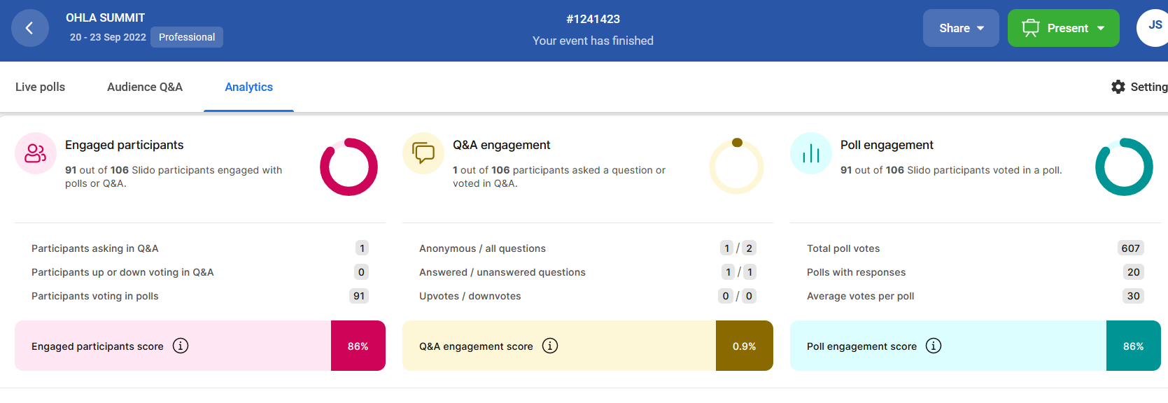
Individual Question Engagement and Results
Team Engagement According to Gallup, managers, more than any other factor, influence team engagement, and performance. What percent of the variance in team engagement is determined solely by the manager? (61 participants)
A)25% (3%)
B) 40% (14%)
C) 70% (50%)
D) 90% (33%)

What is your biggest concern as it relates to the lodging/hospitality industry? (61participants)
Sense of Community 3%
Flexibility/Work-life Balance 58%
Advancement 5%
Pay/Benefits 27%
Empowerment 8%

Longevity According to the Bureau of Labor and Statistics, what is the average length of service in a job for someone in the hospitality industry? A)1 Year B)2 years C) 5 years D)8 years (61participants)
6 months7%
18 months 23%
1 year 30%
2 years 41%

Flexibility According to a Deloitte study, what percentage of workers say they would benefit from work flexibility? With the top gains being less stress, improved mental health & better integration of work and personal life. A) 25% B) 40% C) 71% D) 94% (64 participants)
25% (2%)
57% (0%)
71% (3%)
94% (95%)

Students, Which area of lodging are you most interested in? Choose one... (17participants)
Sales 12%
General Management 65%
Room Management 6%
Food & Beverage Management18%
Training 0%

Students, When you start a new job which method of training do you learn best? (4 participants)
On-line (reading, watching videos, taking quizzes) 0%
Active Participation/ Doing tasks hands-on 100%
Reading Instructions/procedures related to the tasks using printed material 0%
Discussion/Conversation regarding instructions/procedures related to the tasks 0%
Other 0%

Students, What component of your education do you find most important to your success? (7 Participants)
Coursework 0%
Course Lecture 0%
Internships/Experiential Opportunities in the industry 71%
Networking Opportunities 0%
Advice from the Professor/Instructor 29%

Industry Partners, How long do you see yourself in a Lodging or Hospitality career? (32 participants)
1- 5 years 16%
6-10 years 9%
11-15 years 9%
16-20 years 19%
20 or more years 47%

Industry Partners, Would you recommend a career in the lodging or hospitality industry to your family or friends? (19 participants)
YES 95%
NO 5%

Industry Partners, What is the most rewarding factor in the lodging/ hospitality industry? (19 participants)
Guests 47%
Coworkers 26%
Pay and Benefits 0%
Flexibility 16%
Work Life Balance 11%

Educators, In your observation of students, does having prior hospitality work experience give students an advantage when it comes to classroom/program success? (12 participants)
YES 83%
NO 0%
Individual results Case by Case 17%

Educators, Is an Internship or is completion of an Experiential assignment(s) a requirement of your institution's lodging/hospitality program? (8 participants)
YES 50%
NO 50%

Educators, Do you believe that job experience opportunities within a hotel/hospitality educational program is advantageous to the success of a graduate? (12 participants)
YES 100%
NO 0%

Everyone, Do you believe a career in lodging or the hospitality industry is viewed in a positive light (26 participants)
YES 54%
NO 31%
UNSURE 15%

Everyone, Do you believe that most people understand what is included in the operation of a hotel or hospitality business? (22 participants)
YES 14%
NO 86%
UNSURE 0%

Everyone, Select the college degree and experience you feel should be a requirement for a management career in hospitality.
(28 participants)
No college and at least three years’ experience 46%
Two-year degree and no experience 18%
Two-year degree and two years’ experience 32%
Four degree and no experience 0%
Four-year degree and two years’ experience 4%
___________________________________________

Would you like to attend another Future of Lodging Summit in 2023, tentatively in Cleveland? (33 participants)
YES 94%
NO 3%
MAYBE 3%

Would you like to join a task force to assist the OHLA EDU/WFD Committee with planning next year's summit? (22 participants)
YES 50%
NO 5%
UNSURE 45%

Traveled from what city to attend (63 participants)
- 22= Columbus (34.9%)
- 11= Cleveland (17.4%)
- 4= Dayton (6.3%)
- 2= Bowling Green, Cincinnati, Grove City, Marion, Marysville, New Albany, Sebring, Westerville, Worthington. 2 people representing a town or city (28.5%)
- 1= Canton, Chagrin Falls, Creola, Delaware, Delphos, Dublin, Fredericktown, Hillard, Hocking Hills, Kenton, Lancaster, Lewis Center, Lima, McArthur, Medina, Newark, Orient, Perrysburg, and Strongsville. 1-people representing town/city (30.1%)

Fun fact: 1204 cities/towns in Ohio, 31 were represented: 2.5% of cities and towns within Ohio were represented

What is your most valuable take-a-way from today's summit? (31participants)
3 = Flexibility
3 =Opportunity
2 =Growth, Ownership, Optimism
1 = A sense of home!❤️❤️,Awareness,Collaborate,Collaboration/cooperation,Collaborative,Connections, Cooperation ,Diverse skills, Encouragement, Engagement, Innovation, Inspired and Informed, Inspiring, Knowledge,
Lead not follow, Network, Networking, Opportunities, Opportunity to sell fun, Passion, Positive energy, Pride,
Selling FUN, Value promise, Value proposition, and Vision.
FLIP CHART INSIGHTS

WRITE ONE WORD THAT YOU WOULD USE TO DESCRIBE HOSPITALITY
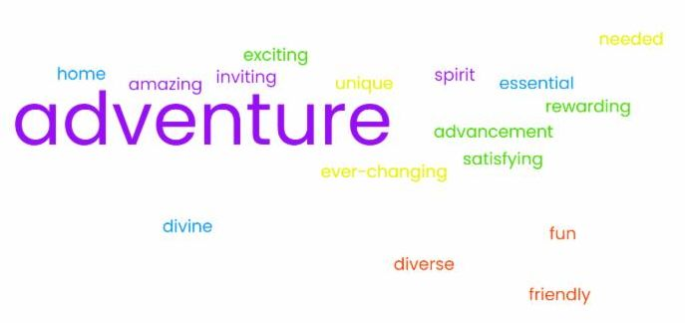

GIVE ONE SUGGESTION TO ATTRACT PEOPLE TO A CAREER IN A HOTEL/LODGING MANAGEMENT POSITION
I like your style
Always be Happy… “I love my job” Who doesn’t love to travel?
When a guest says they can’t wait to come back!
If you want every day to be different, join the hospitality business
If you like to find small ways to make a big difference, join the hospitality industry
If you are willing to learn something new every day
Do you want to travel?
Opportunities to grow and learn every day; increases in pay would be nice too
Work with others who love to serve others- it becomes your 2nd family
Hilton Team Member travel benefits for a lifetime after 20 years-Love to travel-Love people-
Great opportunities
Get to know their wants for a happy career
Get to know them as a person
Hire the right people

